**Practical 2**

**Write a C program to perform the following compliment Operations.**

1. **1’s Complement**
2. **2’s Complement**
3. **1’s Complement:**

#include<stdio.h>

void main()

{

int size,i;

printf("Enter the number of bits do you want to enter :");

scanf("%d",&size);

char binary_number[size+1],onescomplement[size+1];

printf("Enter the binary number: ");

scanf("%s",binary_number);

for(i=0;i<size;i++)

{

if(binary_number[i]=='0')

onescomplement[i]='1';

else if(binary_number[i]=='1')

onescomplement[i]='0';

}

onescomplement[size]='\0';

printf("The 1's complement: %s",onescomplement);

}

**Output:**

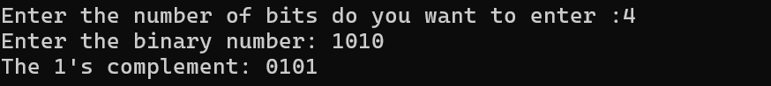

1. **2’s Complement:**

#include<stdio.h>

void main()

{

int size,i,carry=1;

printf("Enter the number of bits do you want to enter :");

scanf("%d",&size);

char binary_number[size+1],onescomplement[size+1],twoscomplement[size+1];

printf("Enter the binary number: ");

scanf("%s",binary_number);

for(i=0;i<size;i++)

{

if(binary_number[i]=='0')

onescomplement[i]='1';

else if(binary_number[i]=='1')

onescomplement[i]='0';

}

onescomplement[size]='\0';

for(i=size-1;i>=0;i--)

{

if(onescomplement[i]=='1'&&carry==1)

{

twoscomplement[i]='0';

}

else if(onescomplement[i]=='0'&&carry==1)

{

twoscomplement[i]='1';

carry=0;

}

else

{

twoscomplement[i]=onescomplement[i];

}

}

twoscomplement[size]='\0';

printf("1's complement: %s",onescomplement);

printf("\n2's complement: %s",twoscomplement);

}

**Output:**

